
Portable Bulkhead Storage Rack
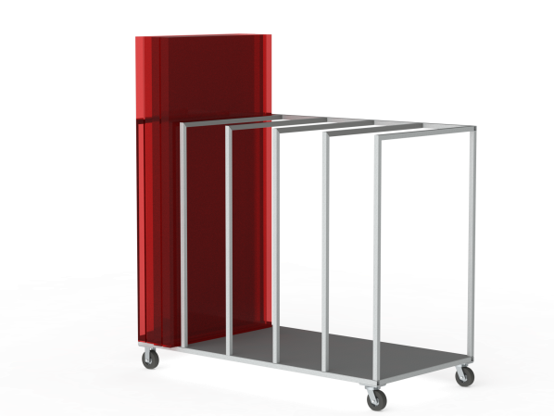

Description: The ITP Portable Bulkhead Storage Rack helps to protect your investment. It will enable operators to easily store bulkheads while not in use. The dedicated storage system utilizes large, rugged, locking wheels that will ensure that bulkheads are readily available and deliverable to where they are needed in any distribution environment.
Features:
- Large, 6” Caster Wheels – Rugged phenolic wheels use a 90 durometer material that will help ensure ease of movement while being pliable enough to endure rough floors and provide better traction in wet environments.
- 7” Ground Clearance – If ease of movement is important, extra clearance under the Portable Bulkhead Storage Rack allows for use of nearly any pallet jack in the industry to move the entire set, quickly and easily, to where needed.
- Rugged Steel Construction- Endures severe conditions while providing a protective envelope around your valuable bulkheads.
- Wheel locks - Available to prevent the load from moving on uneven floors or when accidentally bumped.
- Large Capacity – Each specialized rack allow efficient storage and transportation of up to 10 bulkheads.
Specifications:
Dimensions – 48” (W) x 96” (L) x 78” (H)
Wheel capacity – 1200 Lbs.
Wheel Construction – Phenolic Material / Durometer 90D/Non-marking
Swivel Casters – Steel Frame / Zinc Coated / Large Diameter Swivel Bearings (Sealed)
Frame Construction – Steel
Base Floor Construction – Steel

